1. 5th April midnight

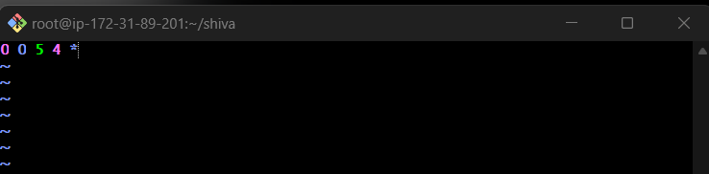

This command will execute at 5th April Midnight

1. 0– This indicates Minutes
2. 0- This indicates Hours
3. 5- This indicates The Date
4. 4- This indicates Month
5. \*- This indicates week

2) 5 th of Every November,Jan,June if it is a Thursday.

1. 0– This indicates Minutes
2. 0- This indicates Hours
3. 5- This indicates The Date
4. 11,1,6- This indicates Month of November, January, June
5. 4- This indicates week i.e., Thursday

3) At 05 and 27th minutes of 9,10,11 hours everyday.

1. 5,27 – This indicates Minutes i.e., This will execute for every 5th and 27th minute
2. 9,10,11- This indicates Hours i.e., This will execute for every 9,10,11th hour
3. \*- This indicates The Date
4. \*- This indicates Month of November, January, June
5. \*- This indicates week i.e., Thursday

4) 34 min. of 9th hour on 15th Aug.

1. 34– This indicates Minutes i.e., This will execute at 34th minute
2. 9- This indicates Hours i.e., This will execute for every 9 hours
3. 15- This indicates The Date
4. 8- This indicates Month of August
5. \*- This indicates week

1. 0– This indicates Minutes
2. 0- This indicates Hours
3. \*- This indicates The Date
4. \*- This indicates Month
5. \*- This indicates week

6) Every Weekend ( Saturday night 11.59 )

1. 59– This indicates Minutes i.e., 59th minute
2. 23- This indicates Hours i.e., 11 pm
3. \*- This indicates The Date
4. \*- This indicates Month
5. 6- This indicates week i.e., This will execute on Saturday

